Part 8 Proposed Sallins Grand Canal Greenway Link

Name: Fergus Carpenter (personal submission)
REDACTED
Introduction

Change is needed to solve the problem of getting Greenway cyclists and walkers safely across the main road. Bringing them across at the bridge would appear to be the best route - similar road crossings operate in several places on the Waterford and Mayo greenways.

Sallins Community Council (SCC) has for many years called for safer walking and cycling routes for the 700 children who attend our local school. Aspects of this plan will help meet this objective; one has the potential to worsen the situation.

- Proposal to close the ramp at Canal View / Sherlockstown Road side of canal

With the exception of one significant issue (see * below) that must be resolved to make this proposal feasible, I support the closure of this ramp for the reasons outlined below.

It will be safer for schoolchildren and Greenway users in two ways:

- Children will not have to cross the ramp while watching for vehicles turning to go down the ramp;
- This pedestrian/cycle ramp will become a safe cycling and walking option to the school, with children then continuing across the new bridge to the school. This has the further advantage of reducing the numbers going across the very narrow canal bridge.

*The issue requiring a solution is that this proposal brings significantly more vehicles turning into a junction (see photo below) that is already very dangerous for pedestrians. SCC has for many years highlighted the dangers for pedestrians crossing at the bottom of this hill – traffic comes in four directions into the junction and pedestrians are not protected.

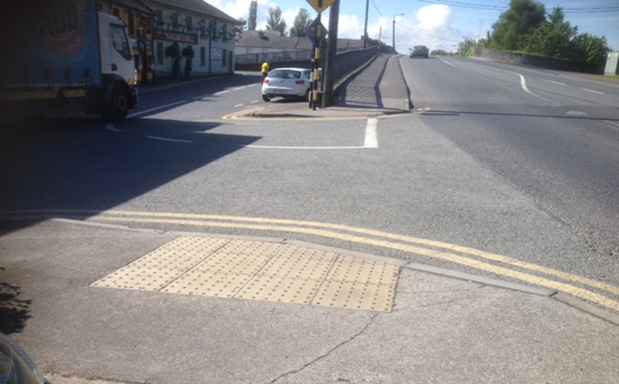

A further complication is that cars at this junction which are turning left to go up the bridge are stalled on an incline and there is roll back, thus making it even more dangerous for pedestrians who often walk behind the stalled vehicle to get across.

This junction must be made safer for pedestrians. As an adult pedestrian with decades of experience crossing town and city junctions, I find this junction very difficult to navigate safely; expecting children and other vulnerable road users to navigate a 4-direction junction with increased traffic is unacceptable and unworkable. A solution needs to be found that will protect vulnerable road users at this crossing.

Reduction of Parking on Canal View / Sherlockstown Road

Many of the businesses in Sallins (particularly the pubs and cafes and fast food eateries – a total of 8) will benefit significantly from the hugely increased human traffic on the Greenway; I would suggest that this, along with the more attractive environment created for customers, will compensate for the removal of customer parking along the canal.

If Greenway users are not attracted by what they see in Sallins, they will not stop over to eat / drink here. On a spring or summer day and at weekends, tourists/ Greenway users will want to sit on the canal bank to observe canal life, not cars. Cars are visually unattractive compared to the canal, trees, nature and nice paving.

The minority of visitors who are car drivers can use the church car park - we are all used to paying for parking everywhere we go. This leaves a short walk of between 50 and 150 metres to all the local eateries. Furthermore, with the pedestrian-friendly nature of the changes proposed and the new pedestrian bridge, this will become a more pleasant walk than is currently the case.

Effect on Traffic Flow
The proposed changes will end cars stopping on the bridge and will bring them to turn at the bottom of the bridge instead. This should have no effect on traffic flow.

There is a possibility that some drivers will decide to turn at the garage instead, thus creating an undesirable situation of these cars driving through the small car park at the derelict shop – this is already hazardous at times, as drivers and some pedestrians share that space.

A yellow box will be needed at the bottom of the bridge so that cars making the turn are not blocked.

- Proposal to close the ramp at Church Avenue / Kerdiffstown road side of canal

This plan proposes to make the temporary closure of the narrow vehicle exit at the western end of Canal View (at the Central Grill) permanent. I warmly welcome this proposal, as it will remove one of the worst danger spots in the town (see below) and will also increase pedestrian safety.

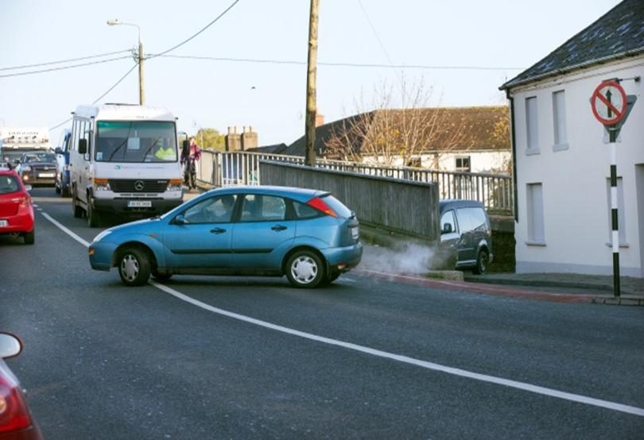

KCC’s proposal also has the advantage of removing the unsafe right ‘blind’ turn from the bridge into Chapel Lane. I generally avoid making this right turn as it is unsafe; it requires removal for road safety reasons.

The road with the church is narrow and traffic will increase significantly here during certain times of the day if this ramp is closed. It will be necessary to remove the two parking spaces and loading bay there and to enforce this. If this isn’t done, there will be traffic chaos at this location, requiring the intervention of the Garda. Finding ways to encourage/enforce a new school drop-off point (see below) will also be crucial in preventing traffic chaos in the period before and after school opening/closure.

The ‘School Run’

Almost all of the students in Sallins N.S. live in Sallins. Most live within a 10 minute walk. As there are almost 700 children attending the school, it is obvious that the vast majority take this walking option.

Parents driving their children to the school create significant safety issues at the school. Occasional attendance by the Garda over the years has not solved this problem.

Two alternative options are possible for this small group of parents. The more feasible option in the short term is to drop children off in the church car park and walk the 150 metres to school. I would encourage KCC and the Garda to work on finding ways of strongly discouraging parents from driving right up to the school building. Many schools have pencil bollards on the edge of the pavement outside school – this is a very basic and minimum requirement to keep cars off the path. Reserving several of the places for disabled parking would also be appropriate.

The second option I propose would have the advantage of solving two problems at once; KCC could create a new walkway to the back of the school through the church grounds that are currently for sale, and Irish Rail would be able to build a much-needed new entrance to the train station. The current entrance to the station is completely unfit for purpose, being inaccessible by wheelchair/pram and dangerous at the entrance.

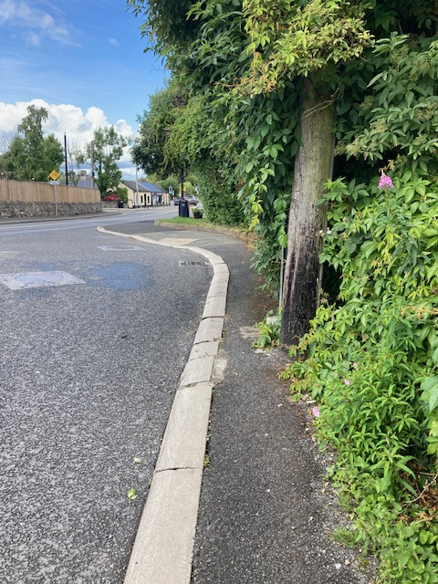
Train Station Entrance

This idea of creating a back entrance point to the school was proposed by Sallins Community Council in 2016 during the Local Area Plan Part 8 process and was accepted by the Council’s CEO as a good idea in his response to submissions.

It would seem appropriate that the cost of site purchase and construction costs would be shared between KCC and Irish Rail.

One of the main objections to this Part 8 proposal is (anecdotally) the traffic chaos that would ensue if the ramp is closed – the two solutions outlined above would significantly mitigate this. The latter option would be an attractive option to residents that would counteract much of the objection to the proposal.

Parking – The Wider Issue

Rather than looking at the parking issue as it currently stands we need to look at it with a fresh and objective perspective. The plan proposes removing 24 spaces - the church car park, having approximately 65 spaces and another 25 at the parish centre beside it, has enough spaces to cope with all current and possibly future demand. Having a car park in the middle of the town close to the large majority of the businesses provides a clear and obvious solution to the parking issues in Sallins.

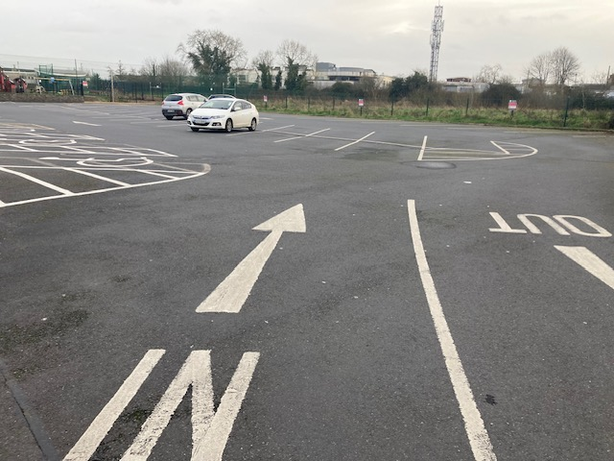
Church Car Park 4.45 p.m., Tuesday 21st Feb.

A visit to many villages and towns around Europe will provide innumerable examples of car parks located on the edge of towns. This is good planning. The need for KCC to agree an arrangement with the church/ parish in relation to this car park is essential. Failure to agree such a solution would be failing the residents of Sallins. All stakeholders (parish, KCC, businesses and residents) should work together to find a solution so that the present and future parking needs are met - with a car park that already exists and is significantly under-utilised.

A time limit would be necessary Monday-Friday to prevent train users from using this car park.

One example of such a parking solution is in Oughterard (Co.Galway) where visitors and residents park their cars in the public car park on the edge of the village and walk the short walk to the local shops.

At Clonea beach (see below) there is an agreement between Waterford Council and a local landowner to allow free parking near the beach.

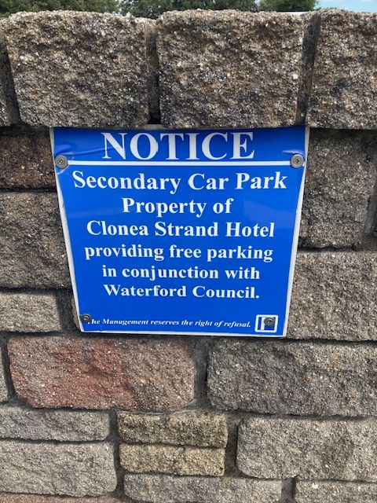

Residents’ Parking
It is unfortunate that the removal of four parking spaces on this side of the canal would affect residents and businesses, and arrangements should be made for these residents to be facilitated nearby. The church park is just 40/50 metres from those parking spaces so would seem, again, to offer a solution.

I wish Kildare County Council well in their endeavours to make Sallins accessible, safe and attractive for residents and Greenway users.

