ST. PETER’S CHURCH TWO MILE HOUSE
225th Anniversary 1790-2015
St Patrick’s Well, Killashee
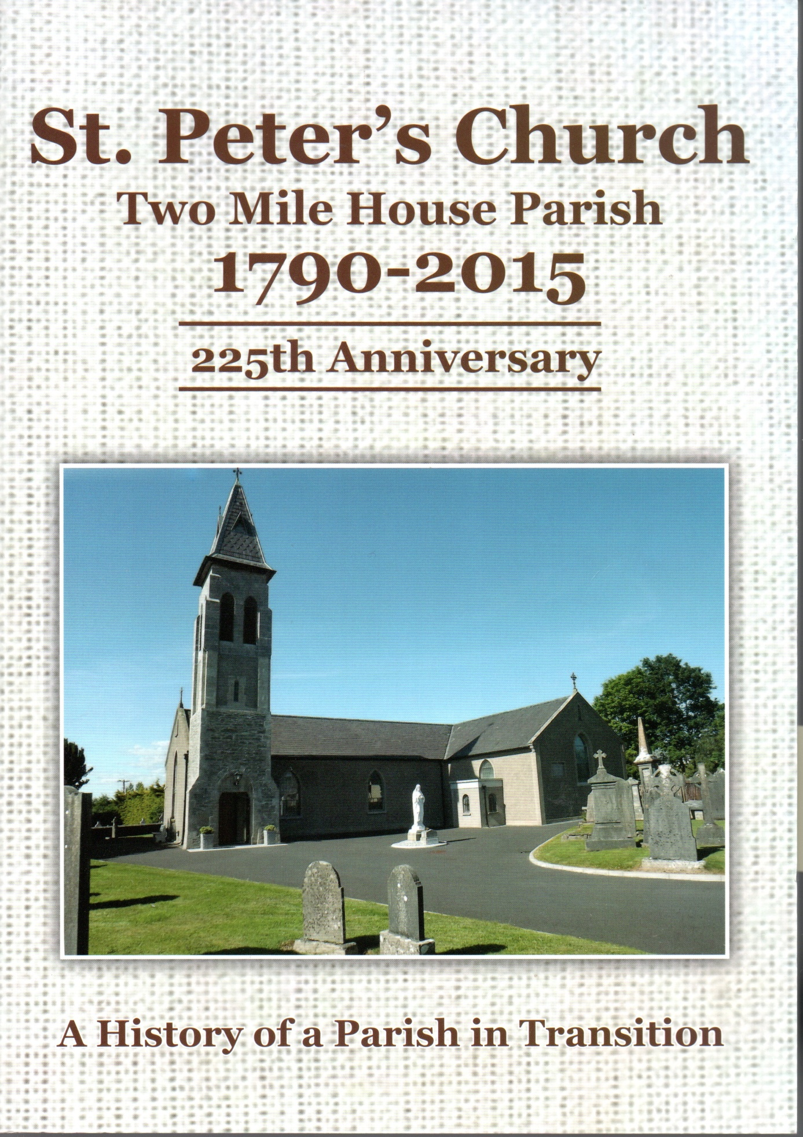

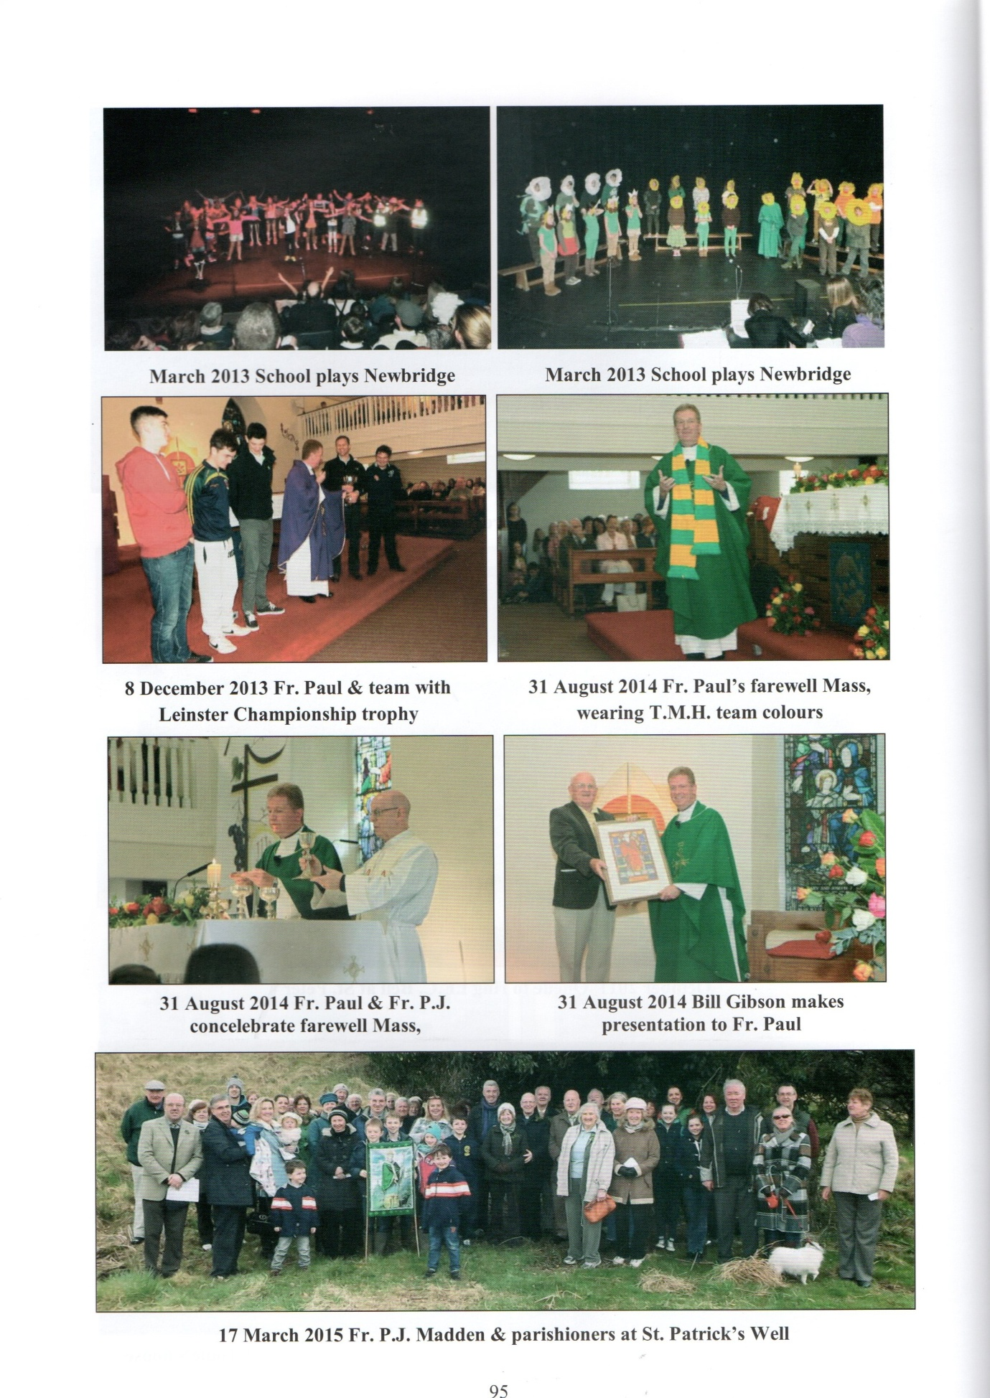
NOTE – The annual pilgrimage to St Patrick’s Well was held on 17th March 2015
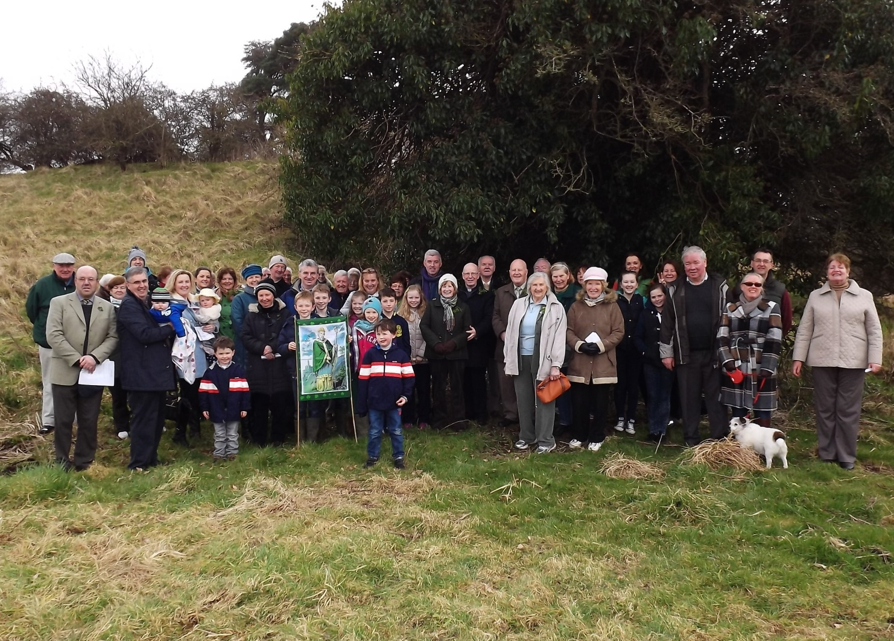
Photo taken at St. Patrick’s Well, Killashee 17th March 2015

