Moth thought extinct found by amateur lepidopterist
By Evelyn Ring
Irish Examiner Reporter 17/02/2018
Moths might not look spectacular, but amateur lepidopterist, Philip Strickland, knew it was a rare find.
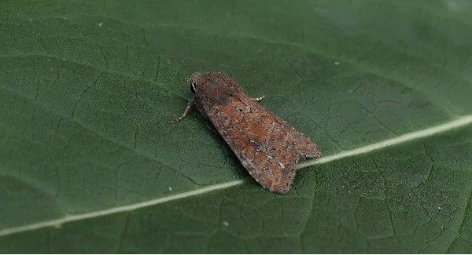
Presumed extinct Moth "Suspecta" found in Lullymore Heritage & Discovery Park

Called The Suspected — Parastichtis suspecta — it was thought to be extinct in Ireland. It was last spotted in 1962.
Mr Strickland found eight of the brown moths in Lullymore Heritage and Discovery Park, in Rathangan Co Kildare, last July, indicating that they were very happy there.
The species inhabits woodland and heath land, and the larvae feed on birch and willow. They are on the wing in late July and August.
It is not known why the moth almost became extinct, but it is believed deforestation and peat-extraction destroyed their natural habitat.
The manager of Lullymore Heritage and Discovery Park, Ray Stapleton, said the park had been used by Bord na Móna for decades to extract peat and once resembled a black desert.
Since 2011, we have been trying to prove that these cutaways are not wastelands, but, potentially, very biodiverse habitats that will also attract tourism to an area that traditionally never had it,” said Mr Stapleton.“The potential for numerous species to thrive in such a diverse habitat is great, as we have seen through Philip’s work.”As well as moths, the park is now home to red squirrels, pine martens, hares, lapwings, buzzards, newts, frogs, and butterflies. Mr Stapleton said a former Irish Examiner columnist, the late Dick Warner, spent many years helping the park to develop the peatland biodiversity area.
“It may take a while to happen, but I firmly believe that this is a win-win situation, as our peatlands biodiversity area is really beneficial to the environment and is key to us attracting tourism from all over the world.”
Mr Strickland said there were about five records of The Suspected from five different sites in Ireland, but the last time it was seen was 56 years ago.
He uses a moth trap that has an ultraviolet light and empty egg cartons. The moths are attracted to the light, make contact with the plastic veins, and drop down into the trap.
“The moths sit happily in the egg cartons, until I release them unharmed, the next morning, into the vegetation nearby,” he said.
“I have been studying moths for more than 20 years, but I do have a desk job.
“I would describe myself as an amateur lepidopterist.”The name ‘lepidopterist’ is derived from the name of the order of butterflies and moths, Lepidoptera.Mr Strickland is a member of Moths Ireland, a group of amateurs and professionals.They collect and collate records for the National Biodiversity Data Centre in Carriganore, Co Waterford.The data centre is funded by the Department of Arts, Heritage, Regional Rural and Gaeltacht Affairs and the Heritage Council. Mr Strickland is planning to continue examining moth species in Lullymore Heritage and Discovery Park this year.
He recorded 201 species there last year.
“The site is proving to be of national significance, with the recording of a considerable number of rare and scarce species,” he said.
“The site is really doing well, as it has a great mix of habitat. The Scots pine and birch woodland, with the undergrowth of bilberry, is a really important native habitat and is producing great records.”
© Irish Examiner Ltd. All rights reserved

