Proposal
We propose the creation of a Marina for residential and touring barges adjacent to the Grand Canal. This amenity would also provide a destination for tourists who are boating, cycling or walking in the area, aligning the boating and natural heritage of the canal with the natural heritage of the Umeras Peatlands Park.
We recommend creating new mooring posts on the canal, a jetty from where kayaks and canoes can be launched, signage to highlight nearby attractions and local history, a service block for all visitors, and bicycle stands.
In conjunction with the objectives of the Umeras Peatland Park group, this proposal shows how the area can be repurposed to provide solutions to two of Ireland’s twenty-first century challenges, lack of housing and climate change, while at the same time attracting tourists and adding to the local economy.
History
This is a still from a 1920’s Pathe News film. This film documented the turf cycle at Umeras, from cutting, stacking, bagging, and then loading onto barges before their onward journey. This image shows a horse towing a barge laden with turf, outside the storehouse in Rathangan.
The barge 29B built in 1909 for the Murphy Brothers in Rathangan, is still in use today and is currently undergoing refurbishment.
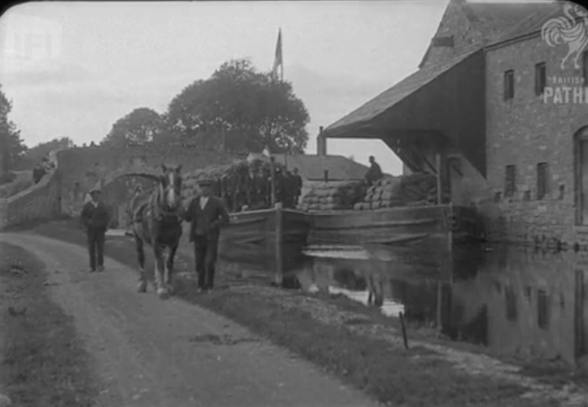
Nearby Attractions
The historic town of Monasterevin has all services, including schools, trains, buses and access to the M7 Motorway.
The Blueway and the Grand Canal links Monasterevin and Rathangan with Lowtown, Dublin, Tullamore and Shannon Harbour to the north. To the south, they provide links with Vicarstown, a hire boat base, and to Athy where it joins the River Barrow and south to Waterford.
The towns of Rathangan, Monasterevin and the Umeras Bog have shared a history with the Grand Canal for over two hundred years.
Ballykelly Mills is being refurbished and will operate as a whiskey distillery and will feature an artisan centre, a visitor centre with reception areas, tasting rooms and an exhibition space.
Benefits
The main benefits of aligning a marina with the Umeras Peatlands Park are to:
- Expand the local housing market by creating a place for residential boaters to moor their ‘tiny homes’
- Provide a cruising destination for touring boats in an area steeped in canal history.
- Create a stopping point for those approaching by land and water on the Blueway
- Link the natural heritage and biodiversity of the canal and towpaths with the peatlands.
- Create work for those providing boating services during the summer and year round
- Provide appropriate infrastructure to support rural tourism and outdoor attractions for all ages and abilities
- Encourage healthy staycations and personal wellbeing and regenerate a rural area
Next Steps
This proposal is an overall look at what is possible at the site. The next step would be to create a feasibility study working with all interested parties, including Kildare County Council, Waterways Ireland (WI) and Bord Fáilte. These organisations have vast experience in the planning and creation of moorings and tourist facilities on Kildare’s inland waterways.
IWAI
For more information on the volunteer work of the Inland Waterways Association of Ireland (IWAI) both nationally and in Kildare see www.iwai.ie and www.iwai.ie/kildare/

Email: kildare@iwai.ie

BACKGROUND INFORMATION
- MARINAS
Features
A Marina located beside a canal, consists of a dedicated basin and services, with land moorings or finger pontoons for each boat.
Potential Customers
It is estimated, there are close to one thousand people living on boats in Ireland and yet, there are very few official moorings. It is a lifestyle that is on the increase on Ireland’s vast stretches of water. There are 26 official residential moorings in Ireland, 20 in Dublin and 6 in Shannon Harbour and a long waiting list for berths. In the meantime, people have bought their barge, craned it into the canal to live somewhere on Ireland’s vast stretches of water.
Ideally a Canal Marina, located with an entrance off the main navigation, will provide moorings for four types of boaters – residential, short stay, winter and long stay.
Residential: A person’s home, with all the comforts associated with a home. Families, couples and singles of all ages, reside on boats in Ireland. For some, their boat is also their office, where they work when not visiting their clients’ or their employer’s offices. Providing facilities for residential moorings is a way of expanding the housing stock for those who chose to embrace this lifestyle.
Short Stay: These boaters may be visiting an area as part of a longer trip. They may require a place to leave their boat on occasion, usually returning to continue their journey within two to four weeks.
Winter berths: Moorings over the winter are required by those boaters who do not travel the waterways from November to March. They require a safe place to leave their boat that is out of the main channel.
Long Stay: Some boaters need a home base. They use their boat during their annual holidays when they take long trips and at weekends when they may cruise within two to three days distance from their home base.
In addition, the canal bank immediately adjacent to a Marina can provide moorings for visiting boats, day trips provided by a local hire boat company and a stopping place and launching pad for kayaks and canoes.
A Marina at Umeras would create a destination for visitors and accomplish one of the objectives of IWAI, encouraging slow tourism. Nav-Watch

Residential Boaters – off the grid
Here is a description of living off-grid by a residential boater. “Boating groups on the canals are low-carbon communities. Disconnected from any communal electricity grid, each boat is responsible for its own electricity and heat generation. They commonly use off-grid electricity production methods such as solar panels and wind turbines to meet their electricity needs. Every electrical appliance is carefully chosen in order to reduce the electrical demand.
Alongside this, the lifestyle of a liveaboard boater is in general, eco-friendly. There is less household waste generated due to space restrictions. Water usage is kept to a minimum as the size of the boat’s water tank limits daily usage – showers not baths! This focus on renewable energy, low waste and water conservation results in a very low carbon lifestyle.’
Sustainable Development
In Ireland, there are many inland Marinas on the Shannon-Erne Waterway, the Ernes, and the Shannon but none on the southern canals. Rural canal sites suitable for Marinas can be viewed as an opportunity to operate environmentally conscious practices and help to maintain sustainable tourism. Where serious work on boats is required, the Drydock in Athy is just 20 km away.
To ensure all marina users are well informed and educated about the eco-systems and sensitivity of the surrounding environment, brochures and berth agreements would need to include information on all environmental and biodiversity topics. See guidelines Blue Flag Marinas
In the future the creation of a small solar powered system for the Park and Marina, as used on many farms in Ireland, would be a useful addition.
- UMERAS PEATLANDS PARK
Because a Marina with other boating amenities would require many of the same type of facilities required by all visitors, it makes sense to be located alongside other tourist attractions.
The plans to allow the surrounding bog to regenerate, planting native trees and grasses, creating a habitat for birds, plants, insects and animals, and supporting biodiversity aims is a great initiative by the Umeras Peatlands Park community. We admire and support what they are achieving and would welcome the opportunity to add another aspect to the regeneration of Umeras Bog.

- EXAMPLES
This is a view of a large rural Marina along a canal in Wales. The entrance from the canal is to the right.
The boats shown are mostly a mixture of wide and narrow beam barges of different lengths, within a 35 to 60 ft range. These measurements are similar to both modern and traditional barges in Ireland. A marina at Umeras might attract 30 boats plus.
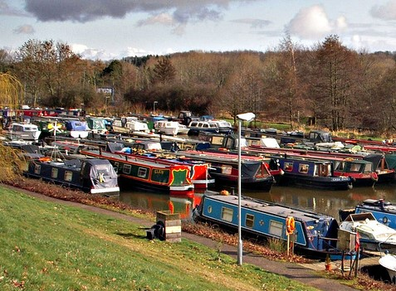
This illustrates the layout of a modern ‘Widebeam’ barge, a popular design with residential boaters in Ireland. The dimensions are similar to the traditional Irish trading boats, many built in the 1920s and 1930s, who plied their trade along the Grand Canal.
