1. **PROPOSAL**

**Create a Recreation Hub that consists of a marina for barges, facilities for walkers and cyclists, a stopping point for tourers in recreational vehicles, overnight glamping pods, all within a green environment showcasing local flora and fauna.**

**Location**

Ticknevin Bog is described as a Cutover Bog, where peat harvesting has been discontinued, usually because it is no longer economically viable to remove any remaining peat.

**Located on the Kildare and Offaly border, near Blundell Aqueduct, part way along the 30km stretch of the Long Level of the Grand Canal, between Ticknevin Lock 20 and Ballycommon Lock 21. The Edenderry to Rathangan road is to the west of the site.**

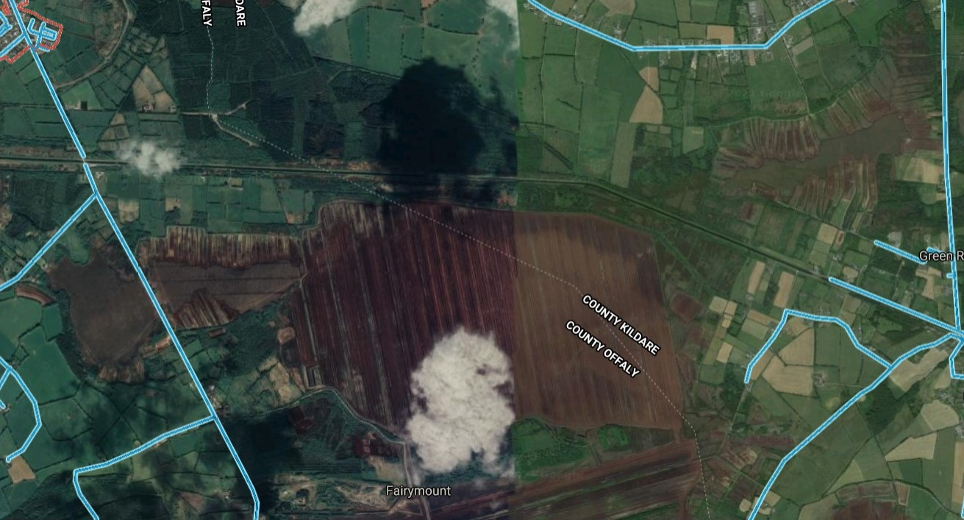

**Benefits**

**Creating a Recreation Hub in Ticknevin Bog:**

* Fills a gap in the local housing market by creating a place for residential barges ‘tiny homes’
* Provides appropriate infrastructure to support rural tourism
* Provides outdoor green leisure facilities for all ages and abilities
* Encourages healthy staycations and personal wellbeing
* Provides jobs in the environs of West Kildare and East Offaly
* Regenerates this rural area
* Provides a trailhead for walkers and cyclists, giving them access to the Canal Greenway
* Provides a stopping point with attractions, for walkers and cyclists
* Provides summer jobs for students living in rural communities

1. **MARINA DESCRIPTION**

**Features**

A Marina consists of a dedicated basin, beside a canal, with land moorings and finger pontoons for each boat. Services may include CCTV security, electricity and water pedestals, rubbish bins and a pump-out service.

LEDs at entrances and on walkways for extra safety. Good Broadband access is a requirement. Larger Marinas may also have a boatyard and chandlery on site or a designated place where visiting marine engineers can work on boats. A service block and parking are also be required for visitors.

**Potential Customers**

Ideally a Canal Marina, located with an entrance off the main navigation, will provide four types of moorings – residential, short stay, winter and long stay.

Residential:These are people who live full-time on their barge. It is their home, with all the comforts associated with a home. Families, couples and singles of all ages, reside on boats in Ireland. For some, their boat is also their office, where they work when not visiting their clients’ or their employer’s offices. Providing facilities for residential moorings is a way of expanding the housing stock for those who chose to embrace this lifestyle.

Short Stay:These boaters may bevisiting an area as part of a longer trip. They may require a place to leave their boat on occasion, usually returning to continue their journey within two to four weeks.

Winter berths: Moorings over the winter are required by those boaters whodo nottravel the waterways from November to March. They require a safe place to leave their boat that is out of the main channel.

Long Stay: Some boaters need a home base. They use their boat during their annual holidays when they take long trips and at weekends when they may cruise within two to three days distance from their home base.

Hire Boats: A Canal Marina may also be a base for a local hire boat company providing day trips and canal holidays.

**Notes**

In Ireland, there are many inland Marinas on the Shannon-Erne Waterway, the Ernes and the Shannon, but none on the southern canals.

To ensure marina users and boaters are well informed and educated about the eco-systems and sensitivity of the surrounding environment, brochures and berth agreements would include information on all environmental and biodiversity topics. See guidelines [Blue Flag Marinas](https://static1.squarespace.com/static/55371ebde4b0e49a1e2ee9f6/t/5899e04286e6c0878c74b495/1486479427145/Marina+Criteria+and+explanatory+notes.pdf)

1. **RECREATION HUB DESCRIPTION**

Because Marinas require many of the same type of facilities as other tourist attractions, it may make economic sense and broaden the support of rural tourism, to build alongside other tourist attractions. Providing extra footfall and therefore, higher return for a shared investment.

Allowing the surrounding bog to regenerate and planting native trees and grasses will create a habitat for birds, plants, insects and animals, and support biodiversity aims. Some of the features in [Lullymore Bog](https://www.lullymoreheritagepark.com/) might be incorporated in this rural setting.

Adding additional overnight parking, a café or restaurant, camping areas and nature trails with signage will attract walkers, campers, cyclists, tourers in recreation vehicles, kayakers and canoeists, and those interested in biodiversity and heritage.

1. **EXAMPLES**

**Marina**

This is an aerial view of a very large Marina located in Wiltshire. The entrance from the canal is to the right. It is not possible to tell which are the residential moorings but they are probably in the upper left corner, where they will not be disturbed by visiting boats. Most rural marinas start small but are designed with expansion in mind.

**The boats shown are a mixture of wide and narrow beam barges of different lengths, but mostly within a 45 to 60 ft range. These measurements are similar to canal barges in Ireland on the Grand Canal which are up to 60ft long, requiring 60ft jetties.**

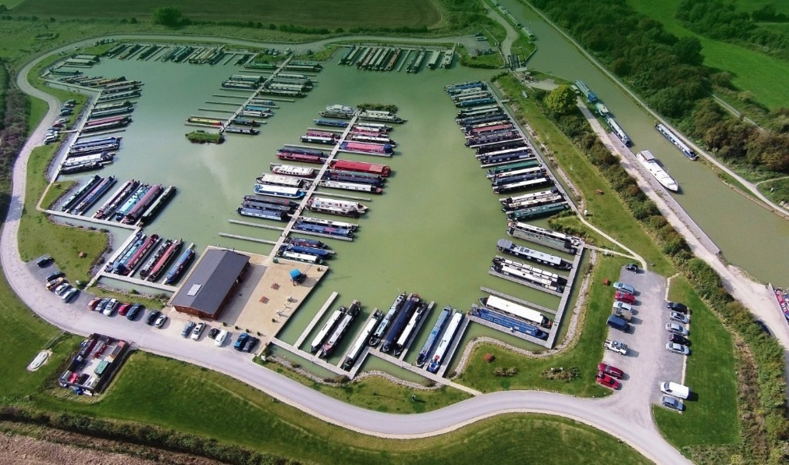

**Residential Barge**

This is an illustration of a modern ‘Widebeam Barge’, a popular design with residential boaters. The dimensions are similar to the traditional Irish trading boats built in the 1920s and 1930s, who plied their trade along the Grand Canal.

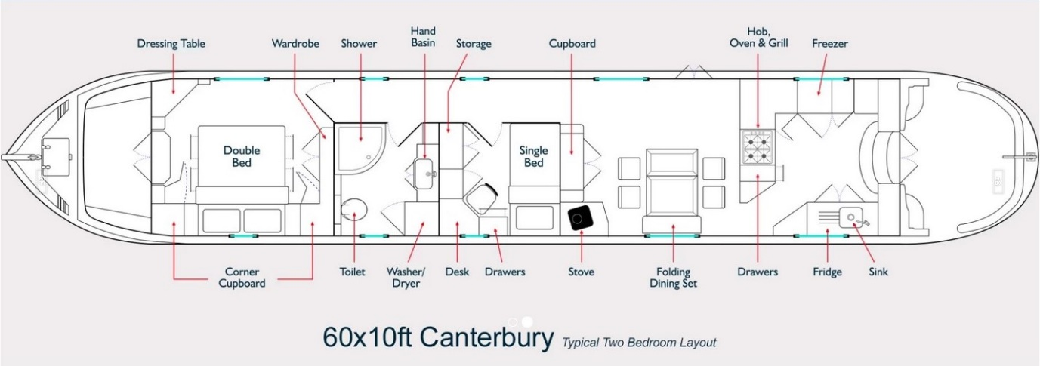

e-mail: [nav-watch@iwai.ie](mailto:nav-watch@iwai.ie)