Allenwood Playground, Co. Kildare

Allenwood Playground and Amenity Areas
Allenwood Enterprise Park Allenwood, Co. Kildare
Screening Report for Habitats Appropriate Assessment

on behalf of
Kildare Co. Council Parks Department

August 2019
Mary O’Connor Consultant Ecologist, Shanacloon Newtown Allenwood ocmary@gmail.com, 0872934467
Contents

Page
1.0 Introduction 1
2.0 Process 1
3.0 Stages of the Appropriate Assessment 2
4.0 Description of the Project 3
5.0 Sources for Information on Natura 2000 sites to Inform Screening Process 5
5.1 Nature Conservation Sites and Available Information 5
6.0 Features of the Development that Could Impact on Natura 2000 Sites 6
6.1 Brief Description of the Natura 2000 Sites 6
116.2 Conservation Objectives 8
6.3 Relevant SAC Description 8
7.0 Likely Impact to the Natura 2000 Sites 11
7.1 SAC Sites 12
8.0 Screening Conclusions 13
Appendices

Appendices
Appendix 1.
Location of Proposed Playground

Appendix 2
Natura 2000 Sites within a 15km radius of the proposed development site

Appendix 3

Photographic record of proposed development site

Introduction

Kildare County Council is proposing to devlop an open access Playground in the grounds of Allenwood Enterprise Park, Allenwood Co. Kildare. Pursuant to proper planning and development Kildare County Council in the Allenwood Local Area Plan Policy NH 8 ensures all proposals/projects are screened to avoid significant impacts on Natura 2000 sites in accordance with Article 6 of the Habitats Directive.
The purpose of this assessment is to determine, the appropriateness, or otherwise, of the proposed project in the context of the conservation objectives of sites which are protected for their natural habitats and species under European legislation, termed Natura 2000 sites.

Process
Ireland became a signatory to the EU Birds Directive in 1979 and the Habitats Directive in 1992. Arising from this legislation was the obligation to establish the Natura 2000 network: nominated sites of highest biodiversity importance for rare and threatened habitats and species across the EU. In Ireland, the Natura 2000 network of European sites comprises Special Areas of Conservation (SACs, including candidate SACs), and Special Protection Areas (SPAs, including proposed SPAs).
SACs are selected for the conservation of Annex I habitats (including priority types which are in danger of disappearance) and Annex II species (other than birds). SPAs are selected for the protection of Annex I birds and other regularly occurring migratory birds and their habitats. The annexed habitats and species for which each site is selected correspond to the qualifying interests of the sites; from these the conservation objectives of the site are derived.
The requirements for an Appropriate Assessments (AA) are fully set out in the EU Habitats Directive 92/43/EEC. Articles 6(3) and 6(4) of this Directive state:
6.3. Any plan or project not directly connected with or necessary to the management of the site but likely to have a significant effect thereon, either individually or in combination with other plans or projects, shall be subject to appropriate assessment of its implications for the site in view of the site's conservation objectives. In the light of the conclusions of the assessment of the implications for the site and subject to the provisions of paragraph 4, the competent national authorities shall agree to the plan or project only after having ascertained that it will not adversely affect the integrity of the site concerned and, if appropriate, after having obtained the opinion of the general public.
6.4. If, in spite of a negative assessment of the implications for the site and in the absence of alternative solutions, a plan or project must nevertheless be carried out for imperative reasons of overriding public interest, including those of a social or economic nature, the Member State shall take all compensatory measures necessary to ensure that the overall coherence of Natura 2000 is protected. It shall inform the Commission of the compensatory measures adopted.
Where a site that is impacted upon by a proposed development hosts a priority natural habitat type and/or a priority species, the only considerations which may be raised are those relating to human health or public safety, to beneficial consequences of primary importance for the environment or, further to an opinion from the Commission, to other imperative reasons of overriding public interest.
The Department of the Environment, Heritage and Local Government (DoEHLG) issued guidance on Appropriate Assessment (Appropriate Assessment of Plans and Projects in Ireland - Guidance for Planning Authorities) in December 2009 which provided advice on the information required in an Appropriate Assessment. Guidance from DoEHLG published in February 2010 stated that it is the responsibility of the competent authority (or consent authority) to undertake the Appropriate Assessment. The assessments may be based on information submitted by the proponent of the plan or project, in the form of a Natura Impact Statement. This Natura Impact Statement must be prepared by an ecological specialist with input from other relevant disciplines as required experts, e.g. engineers, planning specialists, hydrologists.
This screening assessment has been prepared in accordance with the current guidance (NPWS, 2009, Revised February 2010).

Stages of the Appropriate Assessment
This document has been prepared in accordance with the European Commission Environment DG document “Assessment of plans and projects significantly affecting Natura 2000 sites: Methodological guidance on the provisions of Article 6(3) and (4) of the Habitats Directive 92/43/EEC”, referred to as the “EC Article 6 Guidance Document”. The guidance document provides a non-mandatory methodology for carrying out assessments required under Article 6(3) and (4) of the Habitats Directive, and is viewed as an interpretation of the EU Commission’s document “Managing Natura 2000 sites: The Provisions of Article 6 of the Habitats Directive 92/43/EEC”, referred to as “MN2000”. In addition, “Appropriate Assessment Guidance for Planning Authorities” was published by the Department of the Environment, Heritage and Local Government in December 2009 (DEHLG, 2009) and amended in March 2010. Cognisance has been taken of this document in carrying out this screening assessment.
The Habitats Directive promotes a hierarchy of avoidance, mitigation and compensatory measures. In the first instance, the plan should aim to avoid any negative impacts on European sites by identifying possible impacts early in the plan-making and writing the plan in order to avoid such impacts. Following that, mitigation measures should be applied, if necessary, during the AA process to the point where no adverse impacts on the site(s) remain. If the plan is still likely to result in adverse effects, and no further practicable mitigation is possible, then it is rejected. If no alternative solutions are identified and the plan is required for imperative reasons of overriding public interest (IROPI test) under Article 6(4) of the Habitats Directive, then compensation measures are required for any remaining adverse effect.

Screening Phase
This section of the screening process describes the Natura 2000 sites within a 15km radius of the proposed Allenwood, Playground. A 15km buffer zone has been chosen as a precautionary measure, to ensure that all potentially affected Natura 2000 sites are included in the screening process. This is in line with “Appropriate Assessment of Plans and Projects in Ireland – Guidance for Planning Authorities”, produced by the Department of the Environment, Heritage and Local Government.
The integrity of a Natura 2000 site (referred to in Article 6.3 of the EU Habitats Directive) is determined based on the conservation status of the qualifying features of the SAC. The qualifying features for each site have been obtained through a review of online documentation relating to each Natura 2000 site available from the NPWS.
There are no Natura 2000 sites located within the Allenwood urban development area including the area of the proposed Playground site located at Allenwood Enterprise Park. Pollardstown Fen Special Area of Conservation (SAC) is the nearest European site at circa 5.5km from the proposed development site. Table 1 lists the Natura 2000 sites within circa 15km of the proposed Allenwood Playground.

Description of the Project and whether is it required for proper management of an European Site

The project as outlined is not required for the proper management of an European Site i.e an SAC or SPA site.
The project involves the proposed development of a community Playground within the grounds of the Allenwood Enterprise Park, Allenwood. Site location map is included as Appendix 2.
The design of the proposed development takes into account best environmental engineering design to ensure least impact to the environment.
The proposed works are proposed is to include a pedestrian path and, a playground, a multi use game area (porous artificial surface) along with minor landscaping and tree planting works planting.
The construction phase will involve a little soil excavation, movement and reprofiling.
The proposed development extends to a total area of approximately 2,660 square metres at Allenwood Enterprise Park, Allenwood. The proposed site is located adjacent to the A.C.D.A.L. offices and will form a part of a mixed amenity area.
The boundary treatment will retain existing boundary hedgerows will also be maintained.
One entrance will operate as a pedestrian entrance and service access to the playground at the west corner of the playground boundary. The pedestrian entrance approximately 1m wide with a self closing gate and circa 2m gate will give additional width for maintenance and servicing of the playground. The main entrance to the site will be located on the west side of the site providing access to the multi use game area and other amenities is also proposed.
The Playground will contain a range of equipment for children from 1-6 and 6-12 years. The equipment may include the following. Swings, Slides, Rockers, Seesaw, Play Panels, Multi Play Units, Sand & Water Play & landscaping.
It is envisaged that the natural vegetation fringing the site will be retained where possible.
Additional surfaces which may be used in the design of the playground are rubber surfacing, woodchip and sand, these surfaces are permable and will allow drainage to occur to ground on site.
The design may also contain landscape features such as mounding, sand pit, planting and living willow structures and preferentially native tree and shrub planting.
It is likely the construction of the playground will take 12-16weeks from starting on site to completion and opening. This timeframe is dependent on weather and ground conditions.
Any surface water drainage which may be necessary will be attenuated on site.
The construction of the pathway and playground involves the import of construction materials, concrete, tarmacadam and vehicle and machinery operation onsite.
Surface Water Drainage systems will be constructed on site. Soakaways and are proposed to drain any hardstanding areas will be constructed within the proposed development, as required.
Construction of foundations of pathways, and fencing structures will not exceed 500mm in depth.
Landscaping will only use clean uncontaminated topsoils or topsoils excavated from within the site.
Minor scrub clearance may be required in vicinity of, this will not occur within the bird breeding season of 1st of March to 1st of September
Planting schemes will not include any known invasive alien species as defined by Invasive Species Ireland.
All boundary hedgerows and treelines will be retained where possible on site.

General Site Construction Environmental Measures Consistent with Best Practice, Standards, Design and Controls
General Measures
Raw or uncured waste concrete should be disposed of by removal from the site.
The amount of in-situ concreting required should be minimised by maximising the use of pre-cast or permanent formwork.
Ready-mix suppliers should be used in preference to on-site batching.
Washout of concrete trucks should occur off site at a designated, contained impermeable areas, however, if it is necessary to wash down the truck chutes it must be conducted in a dedicated bunded impermeable and signposted wash out area;
Prior to any work it should be ensured that all construction equipment is mechanically sound to avoid leaks of oil, fuel, hydraulic fluids and grease.
Foul drainage from site etc. should be removed to a suitable treatment facility or discharged to a septic tank system constructed in accordance with EPA guidelines.
All vegetation clearance shall be carried out in one period outside the breeding bird’s period which runs from 1st March to the 31st of August.

Runoff and sediment control
Pollution control measures shall be implemented to ensure that pollutants and sediment are not deposited within any local drains

Fuel Management
Fuel management measures will be implemented which will incorporate the following elements: fuels, lubricants and hydraulic fluids for equipment used on the construction site should be carefully handled to avoid spillage, properly secured against unauthorised access or vandalism, and provided with spill containment according to current best practice (Enterprise Ireland BPGCS005)2.
Fuelling and lubrication of equipment should be carried out off site in appropriately contained sites.
Emergency fuel spill kits with oil boom, absorbers etc. will be kept on site in the event of an accidental spill.should be available on site, any spillage of fuels, lubricants or hydraulic oils should be immediately contained and the contaminated soil removed from the site and properly disposed of.
Waste oils and hydraulic fluids should be collected in leak-proof containers and removed from the site for disposal or re-cycling.
Procedures and contingency plans will be set up to deal with an emergency

Waste Management
Waste management measures shall be implemented to ensure that waste generated on site is managed appropriately:
During the construction phase of the project waste will be controlled and segregated appropriately on site by means of dedicated skips which will be disposed of off-site by a licensed waste operator.
It is also important to note that as all trucks transporting materials to and from the site to the site have no potential to transport alien invasive species to the nearby SAC habitats as part of the works. No invasive alien species have been recorded form the area of works so it is highly unlikely that any spread of invasive aliens will occur as a result of site works.

Construction Environmental Management Plan
All environmental measures must be descirded in a site Construction Environmental Management Plan and agreed prior to works.

Sources for Information on Natura 2000 sites to Inform Screening Process

Nature Conservation Sites and Available Information
Data and information about European sites, and other nature conservation sites, were acquired from www.npws.ie. This includes site boundaries, site synopses, lists of qualifying interests (SACs) and special conservation interests (SPAs), and conservation objectives (European sites).
European sites have site specific conservation objectives, and the associated supporting documents were sourced from the NPWS website.
- National Biodiversity Data Centre.

- EISs, NISs and other reports for projects in the general area, including previous Natura 2000 Screening Reports in Allenwood area and Allenwood Green Infrastructure Report held by Kildare County Council.

- Kildare County Development Plan.
- Geological Survey of Ireland Website
- REFERENCES
- Appropriate Assessment of Plans and Projects in Ireland. Guidance for Planning Authorities. Department of the Environment, Heritage and Local Government, 2009.
- Assessment of plans and projects significantly affecting Natura 2000 sites: Methodological guidance on the provisions of Article 6(3) and (4) of the Habitats Directive 92/43/EEC, European Commission Environment DG, 2000.
- Fossitt, J. A. (2000) A Guide to the Habitats of Ireland. The Heritage Council, Ireland.
- Managing Natura 2000 sites: The Provisions of Article 6 of the Habitats Directive 92/43/EEC: European Commission, 2000

Features of the Development that Could Impact on Natura 2000 Sites

Brief Description of the Natura 2000 Sites
This section of the screening process describes the Natura 2000 sites within a 15km radius of the proposed development area. A 15km buffer zone was chosen as a precautionary measure, to ensure that all potentially affected Natura 2000 sites are included in the screening process (Table 1).
All potentially affected Natura 200 sites, numbering 6, withing a 15m radius of the proposed site are included as Appendix 2.

Table 1. Natura 2000 sites within 15km of Proposed Allenwood Playground.
Site Name (code) | Qualifying Interests Habitats and Species | Minimum Distance from Playground (km)
Pollardstown Fen SAC  Site Code 000396 | Annex I - priority habitat  – Calcareous fens with Cladium mariscus and species of the Caricion davallianae [7210]  – Petrifying springs with tufa formation (Cratoneurion) [7220]  – Alkaline fens [7230]  Annex II- species  – Vertigo geyeri [1013]  – Vertigo angustior [1014]  – Vertigo moulinsiana [1016]  – Calcareous fens with Cladium mariscus and species of the Caricion davallianae [7210]  – Petrifying springs with tufa formation (Cratoneurion) [7220]  – Alkaline fens [7230] | 13.8km
Mouds Bog SAC  Site Code 002331 | Annex I - priority habitat  – Active raised bogs [7110];  Annex I -habitats  – Degraded raised bogs still capable of natural regeneration [7120]; and  – Depressions on peat substrates of the Rhynchosporion [7150]. | 12.2km
Ballynafagh Lake SAC  Site Code 001387 | Annex I - priority habitat  - Alkaline fens [7230]  Annex II- species  - Vertigo moulinsiana [1016]  - Euphydryas (Eurodryas, Hypodryas) aurinia [1065] | 8.5km
Ballynafagh Bog SAC  Site Code 000391 | Annex I - priority habitat  – Active raised bogs [7110];  Annex I -habitats  – Degraded raised bogs still capable of natural regeneration [7120]; and  – Depressions on peat substrates of the Rhynchosporion [7150]. | 9 km
The Long Derries, Edenderry SAC  Site Code 000925 | Annex I - priority habitat  Semi-natural dry grasslands and scrubland facies on calcareous substrates (Festuco-Brometalia) (* important orchid sites) | 7.9km

Conservation Objectives
A Natura 2000 site’s conservation objectives are defined by DAHG and are, “intended to ensure that the relevant Annex I habitats and Annex II species present on a site are maintained in a favourable condition” (DEHLG, 2010). The DEHLG guidelines state that, “The Conservation Objectives derive from the qualifying interests, the Natura 2000 standard data form, and the management plan for the site, with summary information also available in the site synopsis.” Whilst the Natura 2000 standard data forms and site synopses do present details of the qualifying features of Natura 2000 sites, and list the generic threats to those features, they do not define the conservation objectives of the site.
For the purposes of this assessment, information on the conservation objectives for the sites has been gained from consultation with NPWS relating to the Border Regional Planning Guidelines and NPWS generic Conservation Objectives for Natura 2000 Sites where no Management Plan is yet available.
Generic conservation objectives for SPAs are as follows:
- To maintain the bird species of special conservation interest for which the SPA has been listed, at favourable conservation status.
Generic conservation objectives for SACs are as follows:
- To maintain Annex I habitats and Annex II species for which the cSAC has been selected at favourable conservation status;
- To maintain the extent species richness and biodiversity of the entire site; and
- To establish effective liaison and co-operation with landowners, legal users and relevant authorities.
The favourable conservation status of a species can be described as being achieved when: population data on the species concerned indicate that it is maintaining itself, and the natural range of the species is neither being reduced nor likely to be reduced for the foreseeable future, and there is, and will probably continue to be, a sufficiently large habitat to maintain its populations on a long-term basis.
Favourable conservation status of a habitat can be described as being achieved when: its natural range, and area it covers within that range, is stable or increasing, and the ecological factors that are necessary for its long-term maintenance exist and are likely to continue to exist for the foreseeable future, and the conservation status of its typical species is favourable as defined below.

Relevant SACs Descriptions and Potential Impact
Pollardstown Fen SAC
Pollardstown Fen SAC is located circa 13.8km south of the proposed Playground development in Allenwood. Pollardstown Fen SAC is a ground water dependent ecosystem and disruption to site hydrology is understood to be the most significant threat to this site. However, there is no direct groundwater hydrological link between the site of the proposed Playground Development lands and this SAC due to the significant distance, sub-surface topography and surface geomorpholgy isolating the sites from one another. Therefore it is envisaged there will be no hydrological disruption to the integrity of the SACs or the habitats or species for which they are designated and no significant impacts to habitats or species likely to occur as a result of the proposed development. There will be no direct loss of habitat or species due to site works located at such a significant distance form this site.

Mouds Bog SAC
Mouds Bog SAC is located approximately 12.2km to the south of the proposed development site. There is no direct catchment ecological or hydrological connectivity from this site to the proposed development site. Mouds Bog SAC is a ground water dependent ecosystem but due to the significant distance sub-surface topography and surface geomorpholgy isolating the sites from one another any potential development in Allenwood is highly unlikely to impact on the groundwater regime of Mouds Bog SAC and therefore will not impact on the integrity of the SACs or the habitats for which they are designated. There will be no direct loss of habitat or species due to site works located at such a significant distance form this site.

Ballynafagh Lake SAC
Ballynafagh Lake is located about 2km north-west of Prosperous in Co. Kildare, circa 8.5km from the proposed development site. It is a shallow alkaline lake with some emergent vegetation. The Blackwood Feeder, which connects Ballynafagh Lake to the Grand Canal, is also included in the site. Ballynafagh Bog SAC and Ballynafagh Lake SAC are all located in the Barrow River Catchment, and so have no direct catchment connectivity to the Allenwood development site which is downstream of the SAC area. Any potential development in Allenwood is highly unlikely to impact on the surface water or groundwater regime of these SACs and therefore will not impact on the integrity of the SACs or the habitats and species forwhich they are designated. There will be no direct loss of habitat or species due to site works located at such a significant distance form this site.

Ballynafagh Bog SAC
This site is a raised bog situated about 1 km west of Prosperous in Co. Kildare circa 9km from the proposed development site. The area is directly underlain by muddy, fossiliferous limestones, interbedded with calcareous shales. The subsoils are predominantly clay-rich tills. All are of low permeability. The site comprises a relatively small core of uncut high bog (approx. 70 ha), which is surrounded by a more extensive area of cutover bog (approx. 90 ha). The high bog area can be divided into a wet core of active bog which covers an area of 23 ha, surrounded by approximately 44 ha of degraded raised bog which is experiencing drying-out at present.
The proposed development site has no direct catchment connectivity from this site to the proposed development site. Ballynafagh Bog SAC is a ground water dependent ecosystem but due to the significant distance sub-surface topography and surface geomorpholgy isolating the sites from one another any potential development in Allenwood is highly unlikely to impact on the groundwater regime of Ballynafagh Bog SAC and therefore will not impact on the integrity of the SACs or the habitats for which they are designated. There will be no direct loss of habitat or species due to site works located at such a significant distance form this site.

The Long Derries, Edenderry SAC
The long Derries is an orchid rich grassland site on ridge of glacial esker gravel and tills which has no direct ecological or hydrological link to the proposed development area in Allenwood and is located at a remove of several kilomters from the site. The development works on the Allenwood Playground will not impact on the integrity of the SACs or the habitats for which they are designated. There will be no direct loss of habitat or species due to site works located at such a significant distance form this site.

Receiving Environment-Terrestrial Habitats
The proposed Playground is located adjacent to the Allenwood Community Development Centre, Allenwood Enterprise Park Allenwood, Co. Kildare. The site is underlain by a mineral sub-soil, and some spoil mounds from a previous development. A large portion of the site comprises an old area of hardstanding gravel which allowed vehicle access and and area of vegetation regeneration which formerly support polytunnels.
The site comprises a relict field area meadow, some scrub, disturbed ground and treelines and hedgerows and a gravel entrance driveway.
No annexed habitats occur within the footprint of the development.
The proposed Playground is located at least 8.5 kilometres from nearest SAC
A site visit was carried out in August 2019.
The habitats of the site have been recorded as part of the overall assessment of the site habitat follows (Fossitt 2000).

Habitats of the proposed Playground
The site here supports significant areas of disturbed ground habitat, recolonising bare ground ED3 , as the site was previously utilised as a garden area and supported gardens and polytunnels which have now been moved and allowed natural vegetation regeneration to occur in the site area. Species include Colt’s Foot (Tussilago farfara), Nettle (Urtica dioica), Dandelion (Taraxacum spp.), willow-herbs (Epilobium spp.) and ragworts (Senecio spp.). Field forget-me-not (Myosotis arvensis) docks (Rumex crispus, R. obtusifolius), Germander speedwell (Veronica chaemydrys), Wall lettuce (Latuca muralis), Hawkbits (Hieracium spp.) and and interesting non native species often associated with disturbed ground Canadian fleabane (Erigeron canadensis).
Relict meadow mosaic habitat comprising damp and drier areas the drier patches support a variety of grasses, broadleaved herbs such as Daisy (Bellis perennis), Dandelion (Taraxacum spp.), clovers (Trifolium spp.) and plantains (Plantago spp.) are common. Dry meadows GS2 which is dominated by coarse and tussocky grasses such as False Oat-grass (Arrhenatherum elatius) and Cock’s-foot (Dactylis glomerata) and Red Fescue (Festuca rubra). Other grasses include Yorkshire-fog (Holcus lanatus) and Smooth Meadow-grass (Poa pratensis) abundatnt broadleaf species include Hogweed (Heracleum sphondylium), Common Knapweed (Centaurea nigra), and Bush Vetch (Vicia sepium) the grassland is becoming inaveded by scrub mostly willows, young oak, and some ash and sycamore. Bramble and an abundance of bracken ferns occurs in the field adjacent to the proposed development site, this corresponds to the habitat Dense bracken HD1.
The hedgerows and treelines at the site are ornamental dominated by non native species and some Bramble (Rubus fruticosus agg.), in addition there are many other native and non-native trees and shrubs growing through the site including, for example, Ash (Fraxinus excelsior), Elder (Sambucus nigra), and willows (Salix spp.) Spuce and dogwoods (Cornus spp.).
Ecological Value
The site is highly modified and managed and is of general low habitat and species value with the scrub and meadow comprising the main ecological interest of the site.
The development of this previously developed are will not lead to any deleterious impact to the ecology of the general area, where possible small scale features such as treelines and hedgerows will be retained as part of the development plan.

Annexed Habitats
Annexed habitats do not occur in the area of proposed works.

Likely Impact to the Natura 2000 Sites
The possible impacts that might arise from the proposed development have been examined in the context of the factors that could potentially affect the integrity of the Natura 2000 sites. As part of the screening stage process the proximity and qualifying interests of the Natura 2000 sites in the wider hinterland of the proposed town park at Allenwood Enterprise Park, Allenwood were considered. In assessing the sites that could potentially be impacted by the proposed development a source-pathway-receptor model was used. All sites potentially impacted were considered in relation to the size and nature of the proposed development and the sensitivity of the receptors in the wider locality. If a Natura 2000 site of particular significance/relevance exists beyond a nominal screening area this was also included in the screening appraisal. Accordingly, all potential pathways for impact on designated sites were included in this screening exercise both within and outside a nominal 15km zone which was chosen to display the location and discuss sites most proximate to the proposed development. Table 2 summarises the location and qualifying interests of designated sites in the area.

SAC Sites
The nearest SAC within the 15km distance from the proposed development site lies at a distance of 8.5km from the prosposed site and are not hydrologically or directly linked by habitat connectivity to the area of the proposed development site at Allenwood Enterprise Park. It is therefore highly improbable that a project of this nature and scale will have any measurable impact on the qualifying interests of these SACs i.e. Red Bog SAC, Ballynafagh Lake SAC and Ballynafagh Bog SAC, Mouds Bog SAC, Pollardstown Fen SAC or Polaphouca Reservoir SPA. For these European sites there will be no reduction in habitat area of qualifying interest, no disturbance to key species or habitats, no reduction in species density or no changes in key indictors of conservation value.
Table 1 summarises the location and qualifying interests of designated sites in the within a 15km radius of the proposed development site.
Table 2 outlines a screening matrix for potential impacts to the SAC sites.
All surface water and foul water on site are adequately treated and therefore no impact is envisaged for surface or ground water quality as a result of the proposed development.

Table 2.
Site Name | Reduction in Habitat Area of Habitat of Qualifying Interest | Disturbance to Key Habitats or Species | Habitat or Species Fragmentation | Reduction in Species  Density | Changes in Key Indicators of Conservation Value
 | Possible Potential Impacts | Possible Potential  Impacts | Possible Potential  Impacts | Possible Potential  Impacts | Possible Potential  Impacts
Red Bog SAC | No | No | No | No | No
Ballynafagh Bog SAC | No | No | No | No | No
Ballynafagh Lake SAC | No | No | No | No | No
Mouds Bog SAC | No | No | No | No | No
Pollardstown Fen | No | No | No | No | No
The Long Derries, Edenderry SAC | No | No | No | No | No

Cumulative Impact
A requirement of the AA process is to take into consideration any cumulative impacts as a result of other plans in the area. It is considered that because of the small scope and scale of the proposed development and the fact that it is highly unlikely to lead to any adverse impact to any Natura 2000 sites within a 15km radius of the site, no culmulative impact will result from the proposed development in combination with any other proposals in the Allenwood area.

8.0 Screening Conclusions
The likely impacts that will arise from the proposed development of works have been examined in the context of the key environmental factors that could potentially affect the integrity of the Natura 2000 network, e.g. disturbance, habitat loss, etc. and the results of the Screening Assessment, as presented in Tables 2. The tables indicate “no” for sites where no negative impact is anticipated on the conservation objectives or on the overall integrity of the site.

Conclusion of screening stage
In conclusion, to determine the potential impacts, if any, of the proposed Allenwood Town Playground on nearby Natura 2000 sites, a screening process for AA was undertaken. The proposed development is within 15km of 6 Natura 2000 sites.
It is considered that the proposed development does not include any element that has the potential to significantly alter the favourable conservation objectives associated with the species and habitats, or, interfere with the key relationships that define the structure or function, either alone or incombination with other impacts, of the Natura 2000 sites considered in this document provided that the following is carried out:
The proposed development is completed as described in section 4.
The programme of measures consistent with best practice, standards, design and controls as outlined in section 4 are implemented
It has been objectively concluded during the screening process that none of these sites are likely to be significantly impacted by the proposed Allenwood Town Playground and these are:

- Pollardstown Fen SAC Site Code 000396
- Mouds Bog SAC Site Code 002331
- Ballynafagh Lake SAC Site Code 001387
- Ballynafagh Bog SAC Site Code 000391
- The Long Derries, Edenderry SAC

Appendix 1. Location and Layout of Proposed Playground

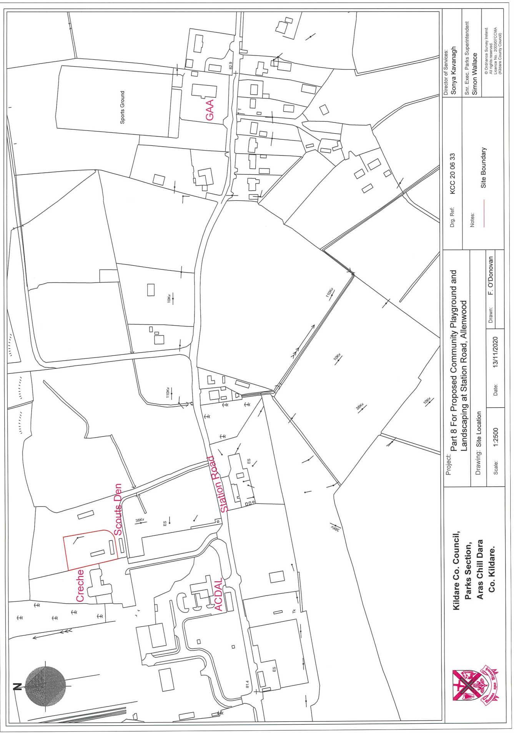

Appendix 2

Natura 2000 Sites within a 15km radius of the proposed development site
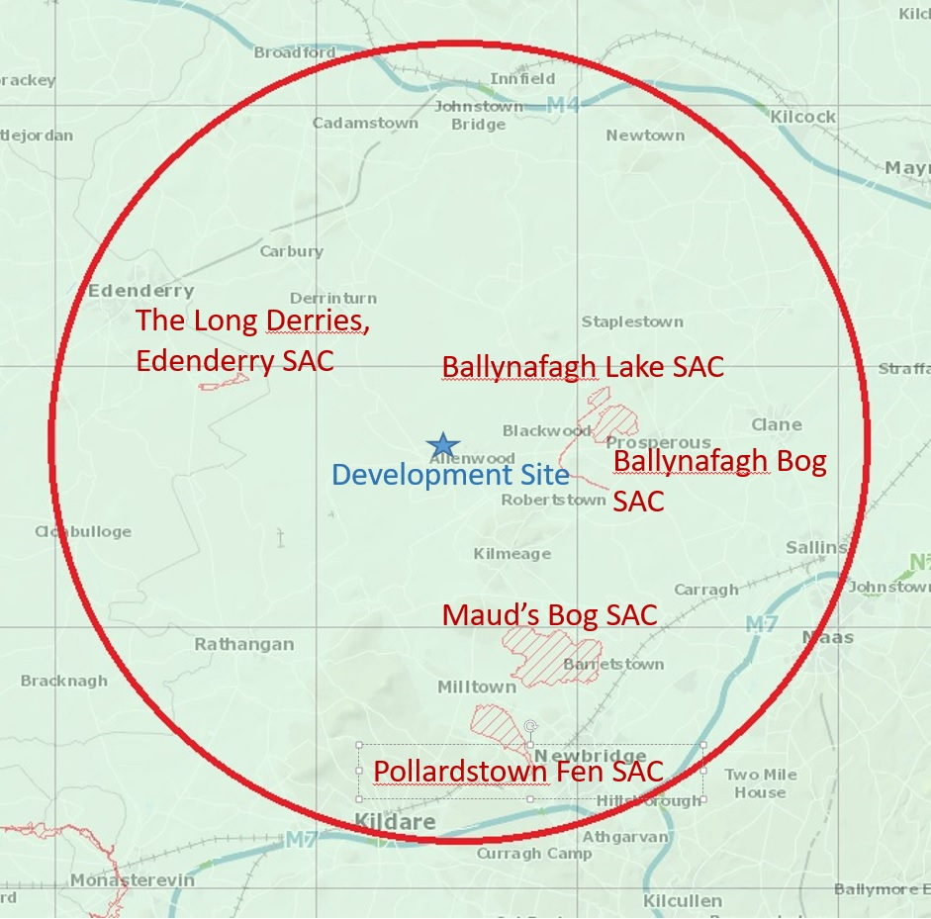

Appendix 3

Photographic Record of Proposed Playground Site Allenwood Enterprise Park Allenwood August 2019

View 1 of area of proposed Playground development site
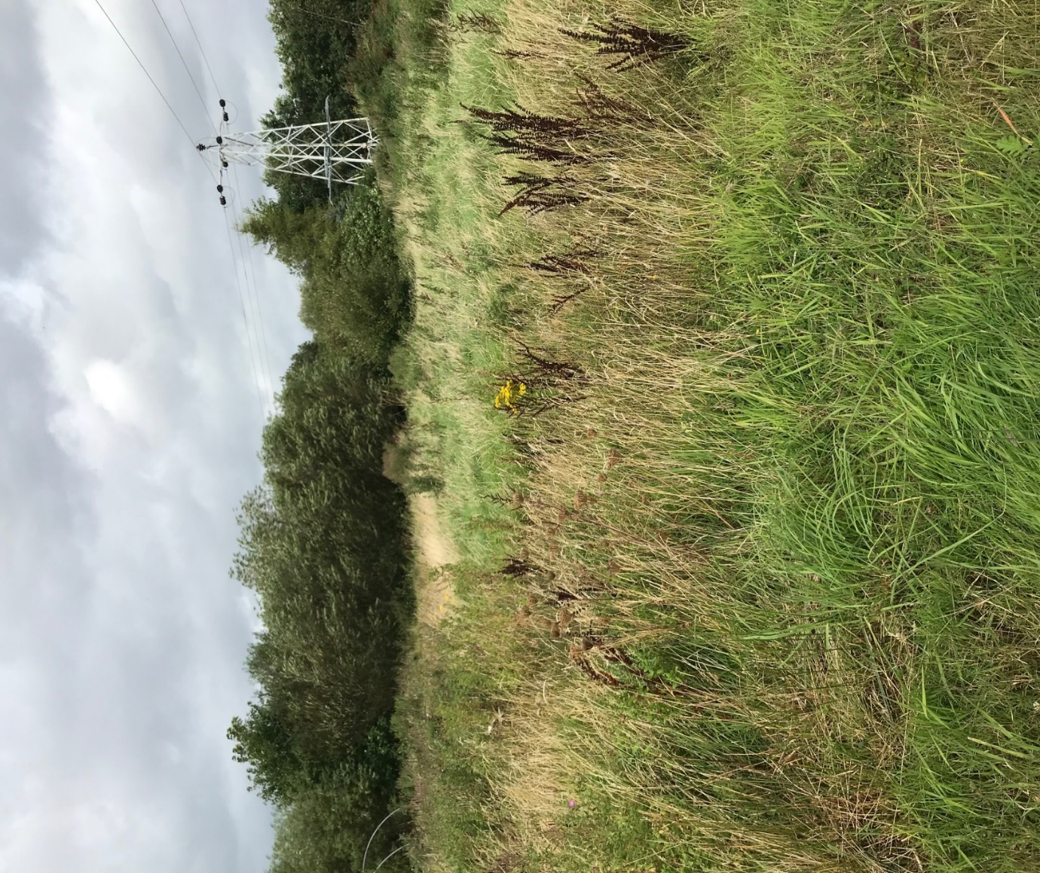

View 2 of area of proposed Playground development site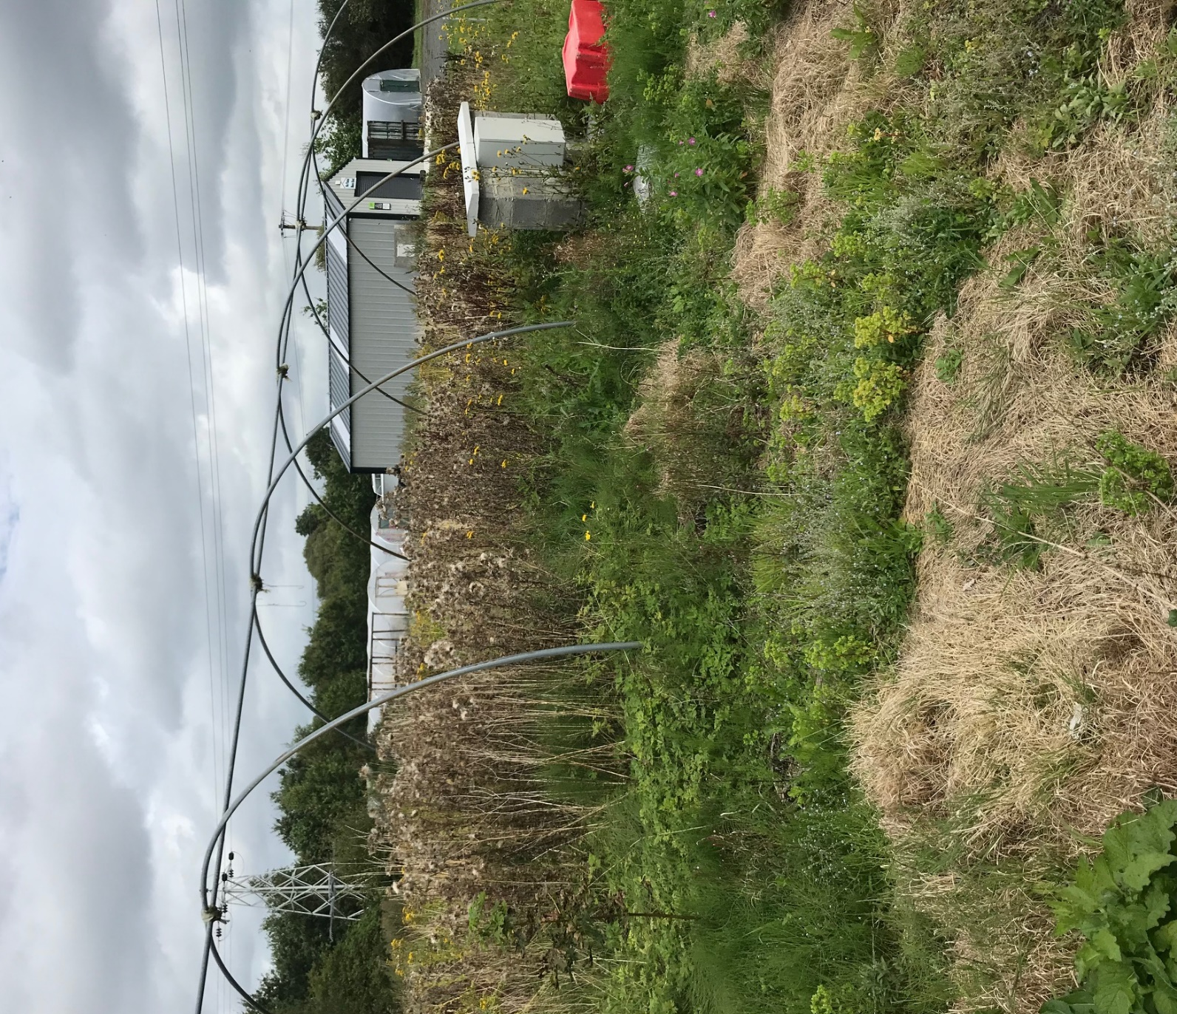

View 3 of vegetation of proposed Playground development site 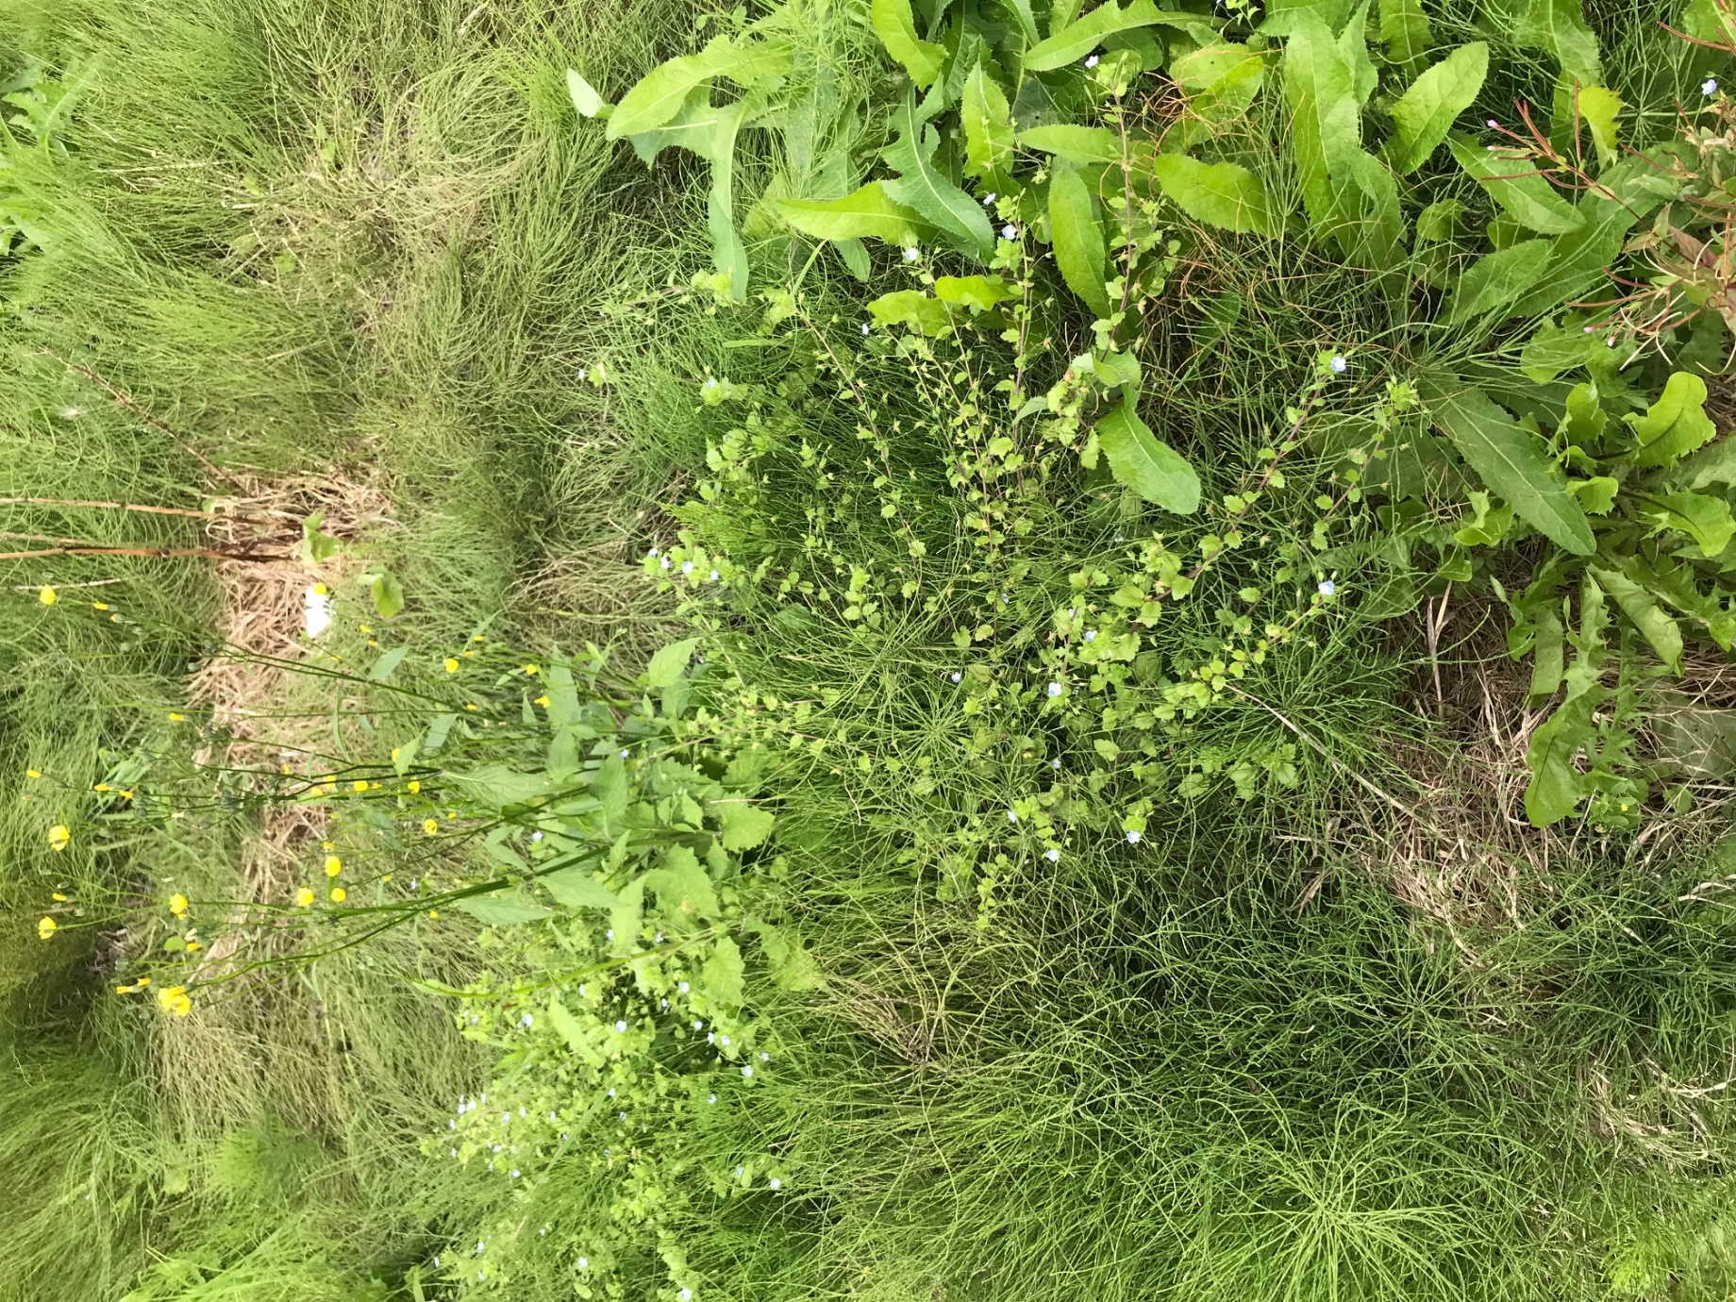
View 3 of area of proposed Playground development site
